Nama : Mu’alim Syahrido

Role : Java Developer

TL : Akhmad Billyasif

Client : XL Axiata

Java 3

Tampilan ERD

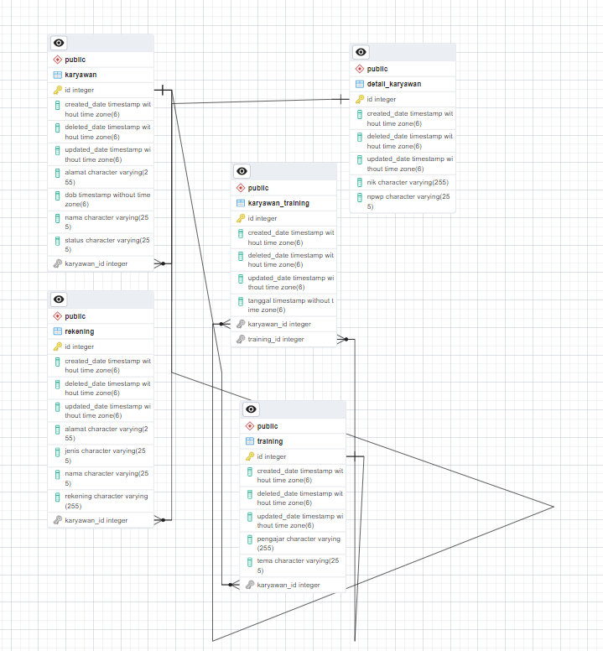

Rest API result:

1. Karyawan + detail

|  |  |
| --- | --- |
| POST- http://localhost:8081/api/v1/karyawans | Request  {      "nama": "Mualim",      "dob": "1996-09-16T09:53:15.603Z",      "status": "active",      "alamat": "Lampung",      "detailKaryawan": {          "nik": "2343212",          "npwp": "584506-32"      }  } |
| Response  {      "code": 200,      "data": {          "createdDate": "2023-09-18T08:35:48.706+07:00",          "updatedDate": null,          "deletedDate": null,          "id": 1,          "nama": "Mualim",          "dob": "1996-09-16T16:53:15.603+07:00",          "status": "active",          "alamat": "Lampung",          "detailKaryawan": {              "createdDate": "2023-09-18T08:35:48.706+07:00",              "updatedDate": null,              "deletedDate": null,              "id": 1,              "nik": "2343212",              "npwp": "584506-32"          }      },      "status": "sukses"  } |
| PUT- http://localhost:8081/api/v1/karyawans | Request  {      "id": 1,      "nama": "Mualim Syahrido",      "dob": "1996-05-07T09:53:15.603Z",      "status": "non active",      "alamat": "Lampung",      "detailKaryawan": {          "nik": "2343234356",          "npwp": "584506-35"      }  } |
| Response  {      "code": 200,      "data": {          "createdDate": "2023-09-18T08:35:48.706+07:00",          "updatedDate": "2023-09-18T08:42:15.095+07:00",          "deletedDate": null,          "id": 1,          "nama": "Mualim Syahrido",          "dob": "1996-05-07T16:53:15.603+07:00",          "status": "non active",          "alamat": "Lampung",          "detailKaryawan": {              "createdDate": "2023-09-18T08:35:48.706+07:00",              "updatedDate": "2023-09-18T08:42:15.095+07:00",              "deletedDate": null,              "id": 1,              "nik": "2343234356",              "npwp": "584506-35"          }      },      "status": "sukses"  } |
| GET- http://localhost:8081/api/v1/karyawans | Request |
| Response  {      "code": 200,      "data": {          "content": [              {                  "createdDate": "2023-09-18T08:35:48.706+07:00",                  "updatedDate": "2023-09-18T08:42:15.095+07:00",                  "deletedDate": null,                  "id": 1,                  "nama": "Mualim Syahrido",                  "dob": "1996-05-07T16:53:15.603+07:00",                  "status": "non active",                  "alamat": "Lampung",                  "detailKaryawan": {                      "createdDate": "2023-09-18T08:35:48.706+07:00",                      "updatedDate": "2023-09-18T08:42:15.095+07:00",                      "deletedDate": null,                      "id": 1,                      "nik": "2343234356",                      "npwp": "584506-35"                  }              }          ],          "pageable": "INSTANCE",          "last": true,          "totalElements": 1,          "totalPages": 1,          "size": 1,          "number": 0,          "sort": {              "sorted": false,              "empty": true,              "unsorted": true          },          "first": true,          "numberOfElements": 1,          "empty": false      },      "status": "sukses"  } |
| GET- http://localhost:8081/api/v1/karyawans/{id} | Request |
| Response  {      "code": 200,      "data": {          "createdDate": "2023-09-18T08:35:48.706+07:00",          "updatedDate": "2023-09-18T08:42:15.095+07:00",          "deletedDate": null,          "id": 1,          "nama": "Mualim Syahrido",          "dob": "1996-05-07T16:53:15.603+07:00",          "status": "non active",          "alamat": "Lampung",          "detailKaryawan": {              "createdDate": "2023-09-18T08:35:48.706+07:00",              "updatedDate": "2023-09-18T08:42:15.095+07:00",              "deletedDate": null,              "id": 1,              "nik": "2343234356",              "npwp": "584506-35"          }      },      "status": "sukses"  } |
| DELETE- http://localhost:8081/api/v1/karyawans | Request  {      "id": 1  } |
| Response  {      "code": 200,      "data": "Sukses",      "status": "sukses"  } |

1. Rekening

|  |  |
| --- | --- |
| POST- http://localhost:8081/api/v1/rekenings | Request  {      "nama": "Mualim",      "jenis": "BRI",      "rekening": "86576594353",      "alamat": "Jakarta",      "karyawan": {          "id": 1      }  } |
| Response  {      "code": 200,      "data": {          "createdDate": "2023-09-18T10:11:49.864+07:00",          "updatedDate": null,          "deletedDate": null,          "id": 1,          "nama": "Mualim",          "jenis": "BRI",          "rekening": "86576594353",          "alamat": "Jakarta",          "karyawan": {              "id": "1",              "nama": "Mualim"          }      },      "status": "sukses"  } |
| PUT- http://localhost:8081/api/v1/rekenings | {      "id": 1,      "nama": "Mualim Syahrido",      "jenis": "BRI",      "rekening": "45482154487",      "alamat": "Lampung",      "karyawan": {          "id": 1      }  } |
| {      "code": 200,      "data": {          "createdDate": "2023-09-18T10:11:49.864+07:00",          "updatedDate": "2023-09-18T10:34:22.715+07:00",          "deletedDate": null,          "id": 1,          "nama": "Mualim Syahrido",          "jenis": "BRI",          "rekening": "45482154487",          "alamat": "Lampung",          "karyawan": {              "id": "1",              "nama": "Mualim"          }      },      "status": "sukses"  } |
| GET- http://localhost:8081/api/v1/rekenings | Request |
| Response  {      "code": 200,      "data": {          "content": [              {                  "createdDate": "2023-09-18T10:11:49.864+07:00",                  "updatedDate": "2023-09-18T10:34:22.715+07:00",                  "deletedDate": null,                  "id": 1,                  "nama": "Mualim Syahrido",                  "jenis": "BRI",                  "rekening": "45482154487",                  "alamat": "Lampung",                  "karyawan": {                      "id": "1",                      "nama": "Mualim"                  }              }          ],          "pageable": "INSTANCE",          "totalPages": 1,          "totalElements": 1,          "last": true,          "size": 1,          "number": 0,          "sort": {              "sorted": false,              "empty": true,              "unsorted": true          },          "numberOfElements": 1,          "first": true,          "empty": false      },      "status": "sukses"  } |
| GET- http://localhost:8081/api/v1/rekenings/{id} | Request |
| Response  {      "code": 200,      "data": {          "createdDate": "2023-09-18T10:11:49.864+07:00",          "updatedDate": "2023-09-18T10:34:22.715+07:00",          "deletedDate": null,          "id": 1,          "nama": "Mualim Syahrido",          "jenis": "BRI",          "rekening": "45482154487",          "alamat": "Lampung",          "karyawan": {              "id": "1",              "nama": "Mualim"          }      },      "status": "sukses"  } |
| DELETE-http://localhost:8081/api/v1/rekenings | Request  {      "id": 1  } |
|  | Response  }      "code": 200,      "data": "Sukses",      "status": "sukses"  } |

1. Training

|  |  |
| --- | --- |
| POST-http://localhost:8081/api/v1/trainings | Request  {      "tema": "C++ Course",      "pengajar": "Mualim"  } |
| Response  {      "code": 200,      "data": {          "createdDate": "2023-09-18T11:27:53.025+07:00",          "updatedDate": null,          "deletedDate": null,          "id": 1,          "tema": "C++ Course",          "pengajar": "Mualim"      },      "status": "sukses"  } |
| PUT-http://localhost:8081/api/v1/trainings | Request  {      "id": 1,      "tema": "Spring Security Course",      "pengajar": "Mualim"  } |
| Response  {      "code": 200,      "data": {          "createdDate": "2023-09-18T11:27:53.025+07:00",          "updatedDate": "2023-09-18T11:40:42.354+07:00",          "deletedDate": null,          "id": 1,          "tema": "Spring Security Course",          "pengajar": "Mualim"      },      "status": "sukses"  } |
| GET-http://localhost:8081/api/v1/trainings |  |
| Response  {      "code": 200,      "data": {          "content": [              {                  "createdDate": "2023-09-18T11:27:53.025+07:00",                  "updatedDate": "2023-09-18T11:40:42.354+07:00",                  "deletedDate": null,                  "id": 1,                  "tema": "Spring Security Course",                  "pengajar": "Mualim"              }          ],          "pageable": "INSTANCE",          "totalPages": 1,          "totalElements": 1,          "last": true,          "size": 1,          "number": 0,          "sort": {              "sorted": false,              "empty": true,              "unsorted": true          },          "numberOfElements": 1,          "first": true,          "empty": false      },      "status": "sukses"  } |
| GET-http://localhost:8081/api/v1/trainings/{1} | Request |
| Response  {      "code": 200,      "data": {          "createdDate": "2023-09-18T11:27:53.025+07:00",          "updatedDate": "2023-09-18T11:40:42.354+07:00",          "deletedDate": null,          "id": 1,          "tema": "Spring Security Course",          "pengajar": "Mualim"      },      "status": "sukses"  } |
| DELETE-http://localhost:8081/api/v1/trainings | Request  {      "id": 1  } |
| Response  }      "code": 200,      "data": "Sukses",      "status": "sukses"  } |

1. Karyawan-training

|  |  |
| --- | --- |
| POST-http://localhost:8081/api/v1/karyawan-trainings | Request  {      "karyawan": {          "id": 1      },      "training": {          "id": 1      },      "tanggal": "2023-09-17T02:29:43.314Z"  } |
| Response  {      "code": 200,      "data": {          "createdDate": "2023-09-18T13:08:07.712+07:00",          "updatedDate": null,          "deletedDate": null,          "id": 1,          "karyawan": {              "createdDate": "2023-09-18T13:08:07.712+07:00",              "updatedDate": null,              "deletedDate": null,              "id": 1,              "nama": "Mualim",              "dob": "1996-09-16T16:53:15.603+07:00",              "status": "active",              "alamat": "Lampung",              "detailKaryawan": {                  "createdDate": "2023-09-18T10:10:09.490+07:00",                  "updatedDate": null,                  "deletedDate": null,                  "id": 1,                  "nik": "2343212",                  "npwp": "584506-32"              }          },          "training": {              "createdDate": "2023-09-18T11:27:53.025+07:00",              "updatedDate": null,              "deletedDate": null,              "id": 1,              "tema": "Spring Security Course",              "pengajar": "Mualim"          },          "tanggal": "2023-09-17T02:29:43.314+00:00"      },      "status": "sukses"  } |
| PUT- http://localhost:8081/api/v1/karyawan-trainings | Request  {      "id": 1,      "karyawan": {          "id": 1      },      "training": {          "id": 1      },      "tanggal": "2023-09-18T04:08:49.188Z"  } |
| Response  {      "code": 200,      "data": {          "createdDate": "2023-09-18T13:08:07.712+07:00",          "updatedDate": "2023-09-18T13:14:12.538+07:00",          "deletedDate": null,          "id": 1,          "karyawan": {              "createdDate": "2023-09-18T13:08:07.712+07:00",              "updatedDate": "2023-09-18T13:14:12.538+07:00",              "deletedDate": null,              "id": 1,              "nama": "Mualim",              "dob": "1996-09-16T16:53:15.603+07:00",              "status": "active",              "alamat": "Lampung",              "detailKaryawan": {                  "createdDate": "2023-09-18T10:10:09.490+07:00",                  "updatedDate": null,                  "deletedDate": null,                  "id": 1,                  "nik": "2343212",                  "npwp": "584506-32"              }          },          "training": {              "createdDate": "2023-09-18T11:27:53.025+07:00",              "updatedDate": "2023-09-18T13:14:12.538+07:00",              "deletedDate": null,              "id": 1,              "tema": "Spring Security Course",              "pengajar": "Mualim"          },          "tanggal": "2023-09-18T04:08:49.188+00:00"      },      "status": "sukses"  } |
| GET- http://localhost:8081/api/v1/karyawan-trainings | Request |
|  | Response  {      "code": 200,      "data": {          "content": [              {                  "createdDate": "2023-09-18T13:08:07.712+07:00",                  "updatedDate": "2023-09-18T13:14:12.538+07:00",                  "deletedDate": null,                  "id": 1,                  "karyawan": {                      "createdDate": "2023-09-18T13:08:07.712+07:00",                      "updatedDate": "2023-09-18T13:14:12.538+07:00",                      "deletedDate": null,                      "id": 1,                      "nama": "Mualim",                      "dob": "1996-09-16T16:53:15.603+07:00",                      "status": "active",                      "alamat": "Lampung",                      "detailKaryawan": {                          "createdDate": "2023-09-18T10:10:09.490+07:00",                          "updatedDate": null,                          "deletedDate": null,                          "id": 1,                          "nik": "2343212",                          "npwp": "584506-32"                      }                  },                  "training": {                      "createdDate": "2023-09-18T11:27:53.025+07:00",                      "updatedDate": "2023-09-18T13:14:12.538+07:00",                      "deletedDate": null,                      "id": 1,                      "tema": "Spring Security Course",                      "pengajar": "Mualim"                  },                  "tanggal": "2023-09-18T04:08:49.188+00:00"              }          ],          "pageable": "INSTANCE",          "last": true,          "totalPages": 1,          "totalElements": 1,          "size": 1,          "number": 0,          "sort": {              "sorted": false,              "empty": true,              "unsorted": true          },          "first": true,          "numberOfElements": 1,          "empty": false      },      "status": "sukses"  } |
| GET- http://localhost:8081/api/v1/karyawan-trainings/{1} | Request |
| Response  {      "code": 200,      "data": {          "createdDate": "2023-09-18T13:08:07.712+07:00",          "updatedDate": "2023-09-18T13:14:12.538+07:00",          "deletedDate": null,          "id": 1,          "karyawan": {              "createdDate": "2023-09-18T13:08:07.712+07:00",              "updatedDate": "2023-09-18T13:14:12.538+07:00",              "deletedDate": null,              "id": 1,              "nama": "Mualim",              "dob": "1996-09-16T16:53:15.603+07:00",              "status": "active",              "alamat": "Lampung",              "detailKaryawan": {                  "createdDate": "2023-09-18T10:10:09.490+07:00",                  "updatedDate": null,                  "deletedDate": null,                  "id": 1,                  "nik": "2343212",                  "npwp": "584506-32"              }          },          "training": {              "createdDate": "2023-09-18T11:27:53.025+07:00",              "updatedDate": "2023-09-18T13:14:12.538+07:00",              "deletedDate": null,              "id": 1,              "tema": "Spring Security Course",              "pengajar": "Mualim"          },          "tanggal": "2023-09-18T04:08:49.188+00:00"      },      "status": "sukses"  } |
| DELETE- http://localhost:8081/api/v1/karyawan-trainings | Request  {      "id": 1  } |
|  | Response  }      "code": 200,      "data": "Sukses",      "status": "sukses"  } |